# TELE303 Exam Review Point

20 questions

3 hours

No calculators

Testing on understanding/application rather than memorization, but:

Important acronyms

Important theorems (what application uses these?)

Wireless fundamentals 35%

Technologies 15%

Android 50%

## **Transmission**

Analog vs digital

|  |  |
| --- | --- |
| Analog signal | Digital signal |
| Signal intensity varies in a smooth fashion over time  A continuous varying electromagnetic wave that may be propagated over a variety of media, depending on frequency. | Signal intensity varies only on constant levels over time.  A sequence of voltage pulses that may be transmitted over copper wire medium.  Generally cheaper than analog signaling.  Less susceptible to noise inference.  Any digital waveform will have infinite bandwidth.  Suffer from attenuation. |

|  |  |
| --- | --- |
| Analog signal transmission | Digital signal transmission |
| Transmit analog signals without regard to content.  Attenuation limit the length of transmission link.  Cascaded amplifier boost signal energy for long distance but cause distortion.  Analog data can tolerate distortion while introduce error in digital data. | Concerned with the content of signal.  Attenuation endanger the integrity of data. |

**Conversion**:

|  |  |  |
| --- | --- | --- |
|  | Digital data | Analog data |
| Digital signal | Digital to digital conversion  Line coding |  |
| Analog signal | Analog signal -> Digital data(digitization)  Analog to digital conversion  Pulse Code Modulation (PCM)  Delta Modulation (DM)  Digital data <- Analog signal (modulation)  ASK, FSK, PSK and QAM(the combination of ASK and PSK) |  |

Nyquist’s sampling theorem

The sampling rate should be at least 2 * the highest frequency in the signal.

Shannon’s Capacity Theorem:

Capacity = Bandwidth * Log2[1 + SNR], SNRdB = 10Log10[signal power / noise power]

In practice, much lower rates achieved

* Formula just assume white noise
* Impulse noise is not accounted.
* Signal distortion is not accounted.

SNR set the upper bound on achievable data rate

A higher SNR means a high – quality signal, low number of required intermediate repeaters.

Nyquist’s formula:

Capacity = 2 * Bandwidth * Log2[L], L is the level of signals

Free space loss

-Such as. 2* the distance, 10* frequency (recast?)

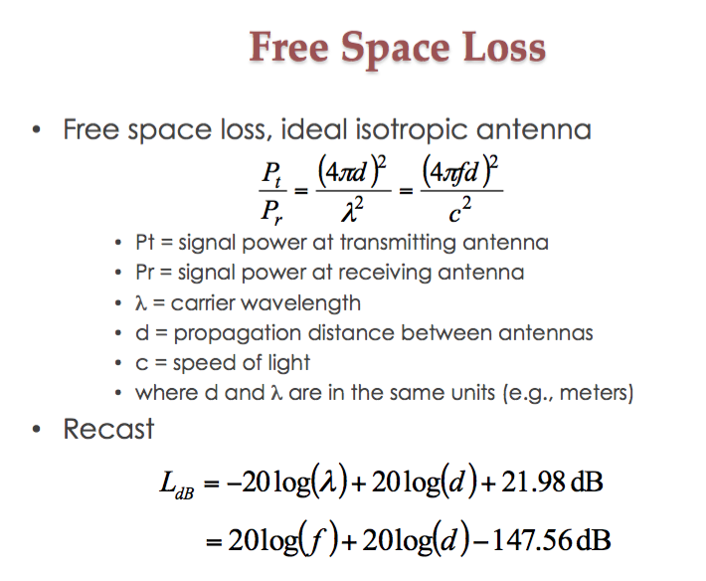

## **Impairments**

List four types of impairments encountered by signal propagating in unguided media

* Attenuation and attenuation distortion
* Noise
* Atmospheric absorption
* Multipath
* Refraction

## **Multiplexing:**

* TDM
* FDM
* CDM
* OFDM

Duplexing:

* FDD
* TDD

|  |  |
| --- | --- |
| FDM | TDM |
| * Take the advantage of the fact that the useful bandwidth of the medium exceeds the required bandwidth of a given signal * Guarded band between channels needed * Easy to implement in analog system | * Take the advantage of the fact that the achievable bit rate of the medium exceeds the required data rate of a signal. * Format flexibility and lower power consumption. * Can be synchronize or statistical. |

|  |  |
| --- | --- |
| FDD | TDD |
| * Easy to implement * Need guard band * Favored in WCDMA | * Synchronization required * Stringent requirement on RTT * Can be made adaptive * Used in TD-SCDMA |

## **Medium access control**

|  |  |  |
| --- | --- | --- |
| TDMA | Flexible data rate  Enable frame by frame monitoring  More efficient, no guard bands needed | Strong synchronization required  More power consumption  Required substantial amount of DSP.  Guard time between slots need to be long enough to cope with delay variance. |
| FDMA | Capacity can scale  Device implementation simple | Capacity scale depend on low SNR  Fixed data rate  Inefficient: guard bands needed  Crosstalk between channel possible |
| CDMA | Walsh Table, need to know use PN code to solve problem | |
| CSMA/CA | Carrier sense multiple access with collision avoidance.  It is invented for wireless communication; collisions are avoided using CSMA/CA’s three strategies:   * The interframe space * The contention window * Acknowledgement     Hidden station problem | |

Also see exposed Terminal problem

## **Spread Spectrum**

What is gained from the waste of spectrum

Frequency hopping

Slow FH, fast FH

MFSK: Learn to draw the hopping, low or fast?

Direct Sequence

* Walsh (preferred in some reason) and PN
* Near far effect, solution to near far effect

FHSS VS DSSS

For FHSS: Frequency hopping spread spectrum use M different carrier frequencies which are modulated by the source signal. During the process, a carrier frequency is selected at one time for every hopping according to the k-bit pattern which is generated by PN.

Carrier frequency hopping according to chips; potential frequency collision; faster hardware required.

For DSSS: Signals multiples by chips; near-far effect (when interfering transmitter get much closer to the receiver than the intended transmitter); require adoptive power control.

## **MANETS**

|  |  |
| --- | --- |
| Flooding | Routing |
|  |  |

Proactive vs reactive outing

|  |  |
| --- | --- |
| Proactive Protocol | Reactive Protocol |
|  |  |

|  |  |
| --- | --- |
| DSR | AODV |
| is Dynamic Source Routing, and is used when the node needs to send a packet to another node, but does not know the route. DSR sends a RREQ for the destination node and each intermediate node appends their own identifier to the packet header before forwarding to the next node. Once the request arrives at the destination node it sends a RREP. The RREP is sent back through the route it came from. | is Dynamic Source Routing, and is used when the node needs to send a packet to another node, but does not know the route. DSR sends a RREQ for the destination node and each intermediate node appends their own identifier to the packet header before forwarding to the next node. Once the request arrives at the destination node it sends a RREP. The RREP is sent back through the route it came from. |

Similarities: they are both reactive protocol, which means they determine route only if when needed, and it is source initiates route discovery.

Differences: DSR include source routes in packets header while AODV maintain route table at nodes. AODV always find the shortest path.

Sensor networks (different between MANET and Routing)?

Secure routing? Solution?

## **Wireless Security**

Security issues:

* Unauthorized access: Authentication
* Data interception: Confidentiality/integrity

CIA: Confidentiality, integrity and availability

Type of attacks and impact:

* Physical and Medium level
  + Weaknesses and improvements: WEP, WPA
  + How to cope with threat
* Network layer and above
  + MAC attack
  + Routing attack
  + Attack in WSN
  + Possible solutions

## **Technologies:**

Cellular

Wireless LANS

Why TDMA improved, to gain higher capacity

Satellites

Wireless sensor networks

|  |  |
| --- | --- |
| GEO | LEO |
| 24 hours a round, over 35000 km, round trip delay is high.  Advantages are: no problem with frequency change, tracking of satellite is simple and high coverage of area  Disadvantages: Weak signal, polar regions are poor served, signal sending delay is substantial.  Usage: global communication, weather forecasting. | 1.5 to 2 hours a round, under 2000 km, less than 20ms.  Advantages: high bandwidth and low communication time lag. Cheater to send satellite into LEO.  Disadvantages: Must cope with Doppler effect, atmospheric drag results in orbital deterioration.  Use: military spy satellite. |

## **Cellular systems**

System architecture

Base station, Mobile telecommunication switching office (MTSO)

Steps in an MTSO controlled call:

* Mobile unit initialization, sense the strongest signal
* Mobile originated call
* Paging
* Call accepted
* Ongoing call
* Handoff

Handoff, soft handoff, CDMA

CDMA: use soft handoff, TDMA and FDMA use handoff

Handoff: mobile station can temporarily connect to more than one base station at the same time.

CDMA’s ad and dis-advantages:

Good: Frequency diversity, multipath resistance, privacy, graceful degradation.

Bad: Near-far effect, self-jamming.

Frequency reuse: Adjacent cells assigned different frequencies to avoid interference or crosstalk.

HOW to increase capacity?

* Adding new channels
* Frequency borrowing
* Cell splitting – cells in high usage area can be split into smaller cells
* Cell sectoring
* Network densification – more cell and frequency reuse
* Interference coordination – tighter control on interference, so frequency can be reused closer to other base station

Need of adoptive power control (why need adoptive)

1. Received power must be sufficiently above the background noise for effective communication.
2. Desirable minimize power in the transmitted signal from mobile.
3. Reduce co-channel interference, alleviate health concerns, save battery power
4. In SS systems using CDMA, it’s necessary to equalize the received power level from all mobile units at the BS.

Generation of standards:

* 1G: analog
* 2G: digital
* 2.5G: digital with some feature of 3G
* 3G: add packets switching, “high” data rate
* 4G: IP based, high bandwidth

Wireless LANs

|  |  |
| --- | --- |
| Advantages | Disadvantages |
| * Convenience * Mobility * Quick development * Expandability * Cost(no wiring cost) | * Security * Range * Reliability * Bandwidth * Frequency allocation * Power consumption * Mobility handoff |

Wireless LAN Range of use:

* LAN extension
* Cross-building
* Ad hoc
* Nomadic

Wireless LAN categories:

* Infrared
* spread spectrum
* narrowband microwave

Multipath issue: Multipath propagation can cause selective frequency fading and inter-symbol-interference.

The solution is OFDM: Orthogonal frequency division multiplexing. OFDM convert a high data rate stream into multiple lower data rate stream, after that parallel streams are modulated onto orthogonal carriers.

The outcome of this is: selective fading channel is divided into flat fading sub channels and because fast data stream is transferred to parallel multiple lower data stream, longer signal symbol can reduce ISI effect.

OFDM compare with CDMA:

CDMA is a single carrier transmission, OFDM is multiple carrier transmission.

OFDM has better performance over Multipath issue.

Lecture notes: important.

Tutorial assignment,

# Android Part

1. The feature of Ubiquitous computing
2. several computing devices.
3. Natural user interface
4. Context awareness
5. Automatic capture and access
6. problem of android fragment

the problem of android fragment is that android operating system becomes fragmented when there is multiple version of OS in use at the same time. This comes from different manufactures adapting a mobile OS for their own device.

1. why do we use prototype?

Can show the process.

Acceptance, Analysis, Definition, ideation, idea selecting, implementation, evaluation

1. If you develop, you have multiple choices, what is your choices, the advantages of each?

3 different types of app models:

Web App: Use HTML and Javascript, Apps relying on existing web data. Example: Bus time tables, online banking apps, not good for complex App logic.

Android App: Use java, this is the choice for most android app, but not good for cross platform or CPU intensive app.

Android Native App: Mix of java and C/C++, good for cross platform, CPU intensive app. Need a lot of development effort

1. A lot of questions about activity stack lifecycle!

Activities are managed by activity stack! How?

Moving through screens by starting other activity, current activity is put on the top of the stack.

Four state: active/foreground, pause, stopped, killed/shut down

Process’s life time is not controlled by application.

What is it, its purpose, what is the idea behind it

Determined by the system, depending on running applications, their importance, available memory.

The importance is listed from low to high as: Empty Process, Background process, Service process, Visible process, Foreground Process.

How does Android handle activities that are currently not visible (e.g. paused or stopped) and how does Android avoid running out of memory? (4 marks)

Activities that are paused or stopped are handle by the activity stack, changing screens starting a new activity will push to current visible screen to the top of the stack.

Android avoid of out of memory by killing program process according to their importance hierarchy. The process life time is managed by system. The level of importance from lowest to highest is: empty process, background process, service process, visible process, foreground process.

1. How xml linked to activity, how does they linked, from java code to xml file to layout?

We define UI components in a layout file, such as activity_main.xml. Then within that activity’s onCreate method, we call the setContentView(R.layout.activity_main) method. This will attach the View hierarchy tree in the layout file to the screen for rendering.

Explain the concept of “Fragments” in Android and why it was introduced. (2 marks)

A [Fragment](https://developer.android.com/reference/android/app/Fragment.html) represents a behavior or a portion of user interface in an [Activity](https://developer.android.com/reference/android/app/Activity.html). ~~You can combine multiple fragments in a single activity to build a multi-pane UI and reuse a fragment in multiple activities~~. You can think of a fragment as a modular section of an activity, which has its own lifecycle, receives its own input events, and which you can add or remove while the activity is running (sort of like a "sub activity" that you can reuse in different activities).

Event handler, implicit intent, event filter

Event listener is an interface in the view class that contain a single callback function (event handler). The callback method will be called by the android framework when the View to which the listener has been registered is trigger by user’s interaction with the item in the UI.

How does Android resolve implicit intents and why can this be a security issue when application components are started with implicit intents? (4 marks)

The Android System searches all apps for an intent filter that matches the implicit intent. Each intent filter specifies the type of intent it accepts based on intent’s **action, data and category**.

It is security issue because you cannot be certain what service will respond to the intent. Specially when there is other app that can handle your app’s implicit intent, so that app can use this to extract sensitive data from you app.

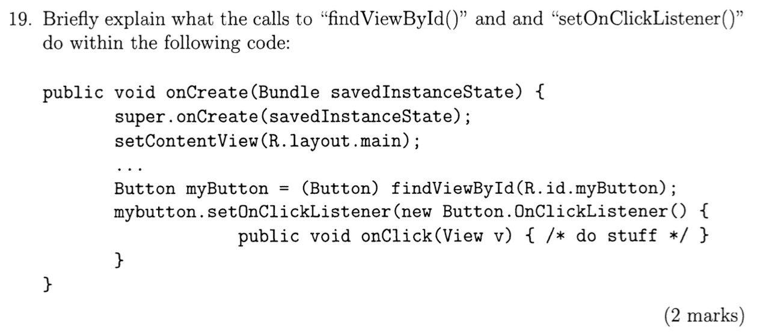

Calling Activity’s method findViewById(int id) will get a reference to a widget. This method accepts a resource ID of a widget and returns a View object. Then cast it into button for further use.

mybutton’s method setOnClickListener accept an object which implement the OnClickListener interface in which you need to implement the event handler onClick method. This is way of using anonymous inner class to register event handler.

What is the meaning of @ and + in the “android: id” tag?

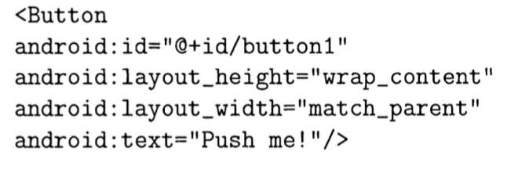

The ”@” indicates the XML parser that it should expand the rest of the ID string and identify it as an ID.

The “+” means that we are create a new resource id, add it to the resources.

1. Thread in Android

Do not block UI thread

Do not touch UI component from thread outside the UI thread

1. Sensors

what is clock bias in GPS?

How to get distance? Why need 4 satellites?

To get an accurate position of receiver we need to not just get the receiver’s geolocation x, y, z but also need to solve the clock bias. So we need total 4 satellites to solve this.

Assisted GPS

what is the biggest advantage?

Fast location acquisition.

Higher precision.

22) Explain the major contribution and idea of Assisted GPS (AGPS) and Differential GPS (DGPS) compared to traditional GPS. (2 marks)

Traditional GPS only use radio signals. To get fast location acquisition and higher precision, AGPS use network information, but need network connection.

DGPS: Enhancement to GPS to increase location accuracy and integrity. DGPS correct errors using a stationary receiver station with a known location, and can calculate delay between position and known position.

Real Time Kinematics (RTK) GPS, if I can measure the phase, then I can improve the accuracy

It means to improve location precision. Similar to DGPS, it also uses a base station and a stationary known location. But instead of just using signal content information, it measures the phase of carrier signal.